Question 2
- Create User
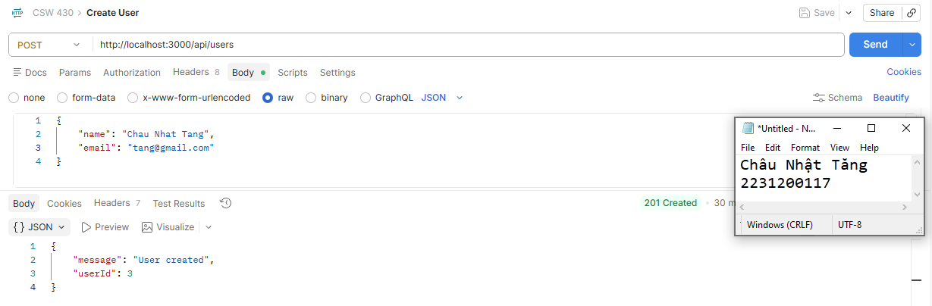
- Get All Users
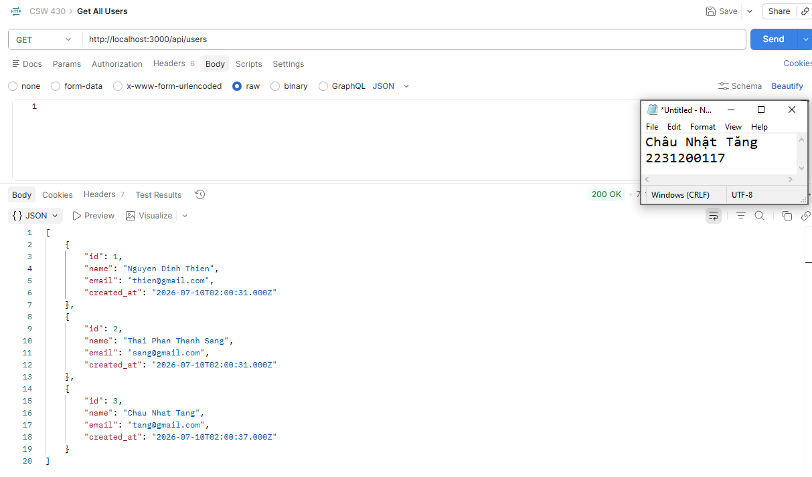
- Get User by Id
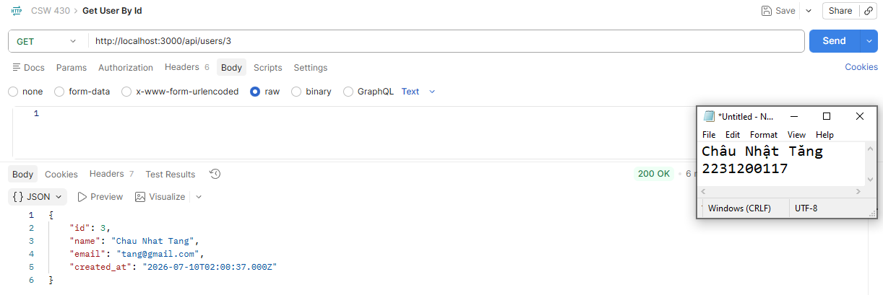
- Update User
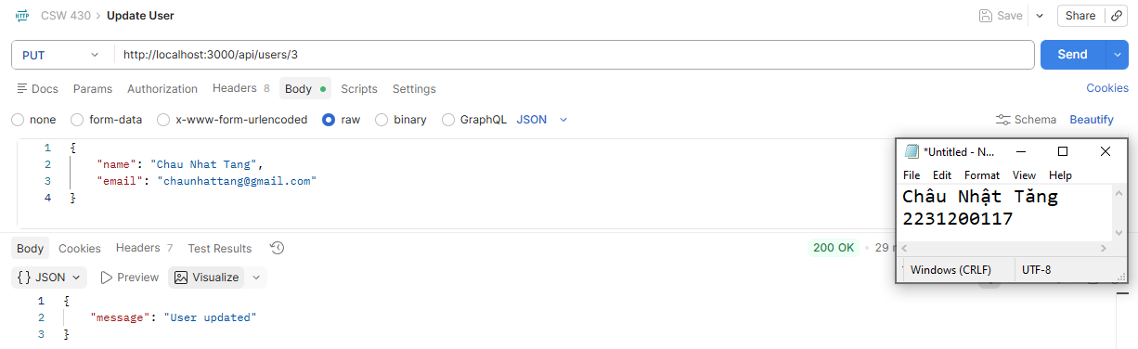
- Delete User
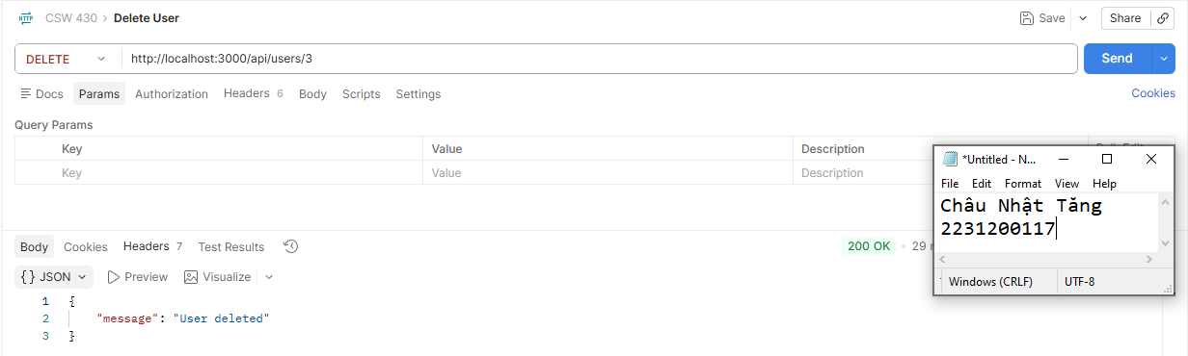
Question 3
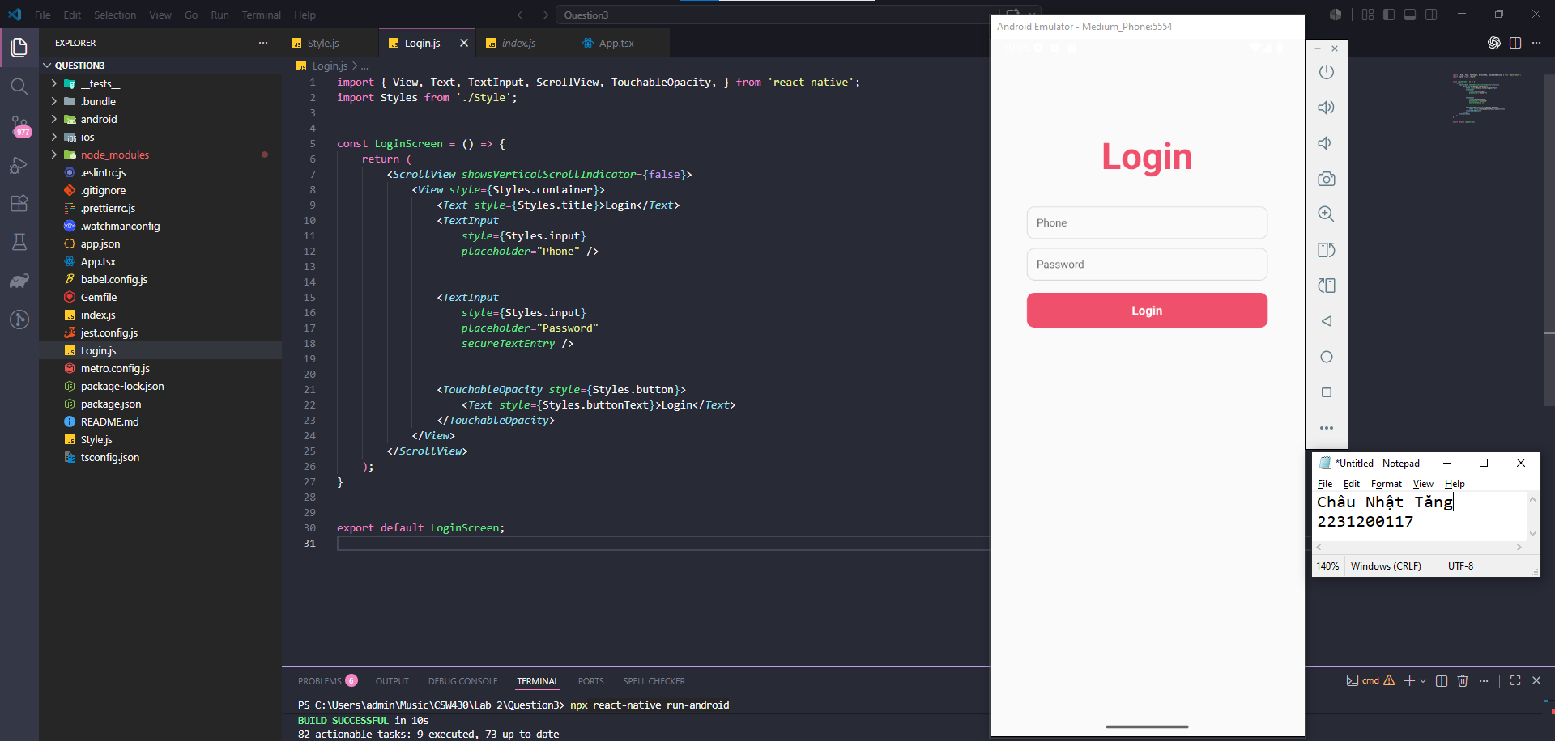

Question 4

